Experiment 6

**Name** : Mohammad Wasi

**SAP ID** : 500110709

**Batch** : AIML B8

Aim: **. To understand the concepts of Views.**

**Objective :**

1. To create a table named EMPLOYEES and populate it with sample data.

2. To create a view named emp_view with specific columns from the EMPLOYEES table.

3. To perform insertion of values into the emp_view by removing the NOT NULL constraint.

4. To demonstrate modification, deletion, and dropping operations on the emp_view.

5. To create a view named salary_view that presents information about employees in department 20 along with their annual salary.

Theory :

Views in databases are virtual tables derived from existing tables or other views. They provide a way to present data without storing it directly. Views simplify complex queries, enhance security, and offer customized data presentations.

**Creating EMPLOYEES Table and Adding Data:**

Establishes a table named EMPLOYEES with predefined columns and populates it with sample data.

**Creating emp_view:**

Constructs emp_view to display specific columns from EMPLOYEES, offering a simplified data representation.

**Inserting Values into emp_view:**

Demonstrates indirect data insertion into emp_view by removing NOT NULL constraints.

Modifying, Deleting, and Dropping Operations on emp_view:

Examples illustrate changes in emp_view affecting underlying tables.

**Creating salary_view:**

Generates salary_view to display department 20 employees and their annual salaries, showcasing customized data views..

**Code**

**-- 1. Create table EMPLOYEES**

CREATE TABLE EMPLOYEES (

Employee_id CHAR(10) PRIMARY KEY,

First_Name VARCHAR(30) NOT NULL,

Last_Name VARCHAR(30) NOT NULL,

DOB DATE NOT NULL,

Salary INT NOT NULL,

Department_id CHAR(10) NOT NULL

);

**-- 2. Insert 6 rows into EMPLOYEES**

INSERT INTO EMPLOYEES (Employee_id, First_Name, Last_Name, DOB, Salary, Department_id)

VALUES

('1', 'M', 'Wasi', '1990-01-01', 50000, 'HR'),

('2', 'Rajneesh', 'Prajapati', '1991-02-02', 60000, 'IT'),

('3', 'Moulik', 'Verms', '1992-03-03', 55000, 'HR'),

('4', 'Eroze', 'Barua', '1993-04-04', 52000, 'IT'),

('5', 'Mukul', 'Shivhare', '1994-05-05', 53000, 'Finance'),

('6', 'Anshika', 'Nar', '1995-06-06', 58000, 'IT');

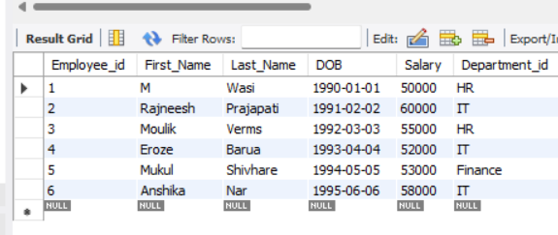

**-- 3. Create View emp_view**

CREATE VIEW emp_view AS

SELECT Employee_id, Last_Name, Salary, Department_id

FROM EMPLOYEES;

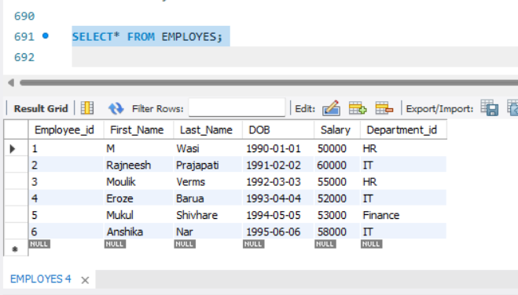

**--4 Creates a view  named salary_view. The view shows the employees in department 20 and their annual salary.**

CREATE VIEW salaA AS

SELECT Employee_id, Last_Name, Salary * 12 AS Annual_Salary

FROM EMPLOYES

WHERE Department_id = 'HR';

SELECT* FROM salaA;

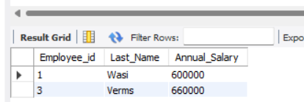

**-- 5. Create a view named salary_view**

CREATE VIEW salaary_view AS

SELECT Employee_id, Last_Name, Salary * 12 AS Annual_Salary

FROM EMPLOYES

WHERE Department_id = 'IT';

SELECT* FROM salaary_view;

